SMI Holiday (M) SDN BHD
98-1-02 Prima Tanjung, Jalan Fettes, Tanjung Tokong, 10470 Penang, Malaysia
Tel: (60)4-890-8131 Fax:(60) 4-890-6364
Email : penjp@smiholiday.com.my
Wendy Tour Website : http://www.smitravel.jp/

SMI PENANG CAR LIST
～Be My Guest～
2014年06月16日
◎ 利用車両一覧
Company | Type | Name | Maker | No. of cars | Seats inc. driver | Max No of Suitcase | Max No. guests
 |  |  |  |  |  |  | APT TRSF | Golf | S/S
SMI | Van | Hiace | Toyota | 1 | 11 | 8 | 8 | 9 | 9
 |  | Hiace | Toyota | 1 | 11 | 8 | 8 | 9 | 9
 |  | Urvan | Nissan | 1 | 11 | 8 | 8 | 9 | 9
Long & Michael | Limousine |  | Mercedes | 2 | 4 | 3 | 3 | 3 | 3
Zarika  Travel | Van | Hiace | Toyota | 4 | 11 | 8 | 8 | 9 | 9
 | Coach | Midium Coach | Hino | 4 | 29 | 28 | 25 | 25 | 28
 | Coach | Midium Coach | Hino | 4 | 31 | 30 | 25 | 25 | 30
 | Coach | Large Coach | Hino | 14 | 45 | 30 | 25 | 25 | 44
Capital One Leisure | Sedan | Proton | Inspira | 2 | 4 | 3 | 3 | 3 | 3
 | Sedan | Proton | Persona | 2 | 4 | 3 | 3 | 3 | 3
 | Sedan | Proton | Perdana | 4 | 4 | 3 | 3 | 3 | 3
 | Sedan | Toyota | Camry | 2 | 4 | 3 | 3 | 3 | 3
 | Van | Toyota | Hiace | 7 | 10 | 7 | 7 | 7 | 8
 | Van | Joylong | Komuter | 1 | 14 | 9 | 9 | 9 | 12
 | Van | Joylong | Farid | 3 | 16 | 12 | 12 | 12 | 14
 | Coach | Large Coach | Hino | 2 | 42 | 25 | 25 | 25 | 41

- SMI保有車
*VAN -10S- NISSAN URVAN

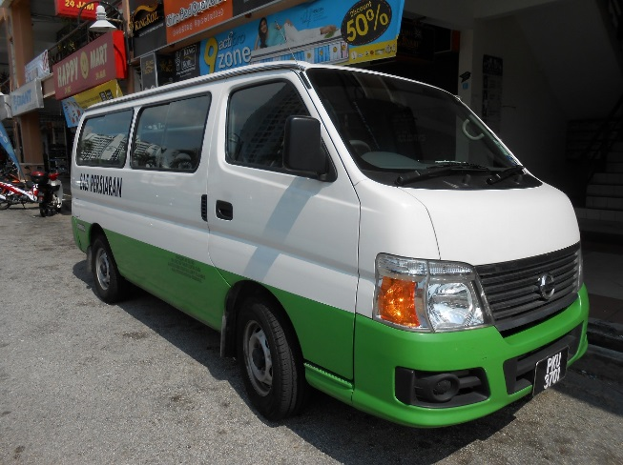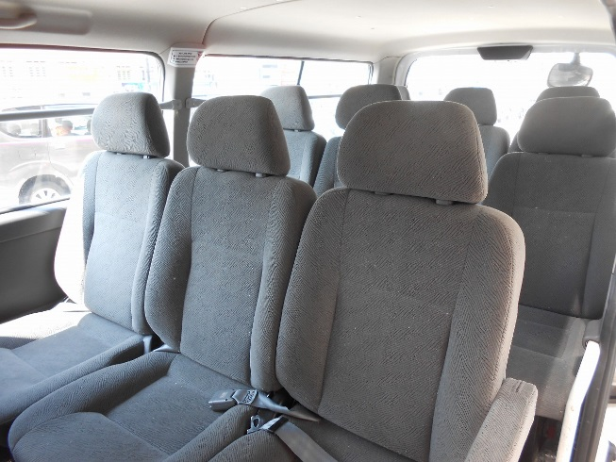

Long & Michael CAR PICTURES

*Limousine - 4S – MERCEDES
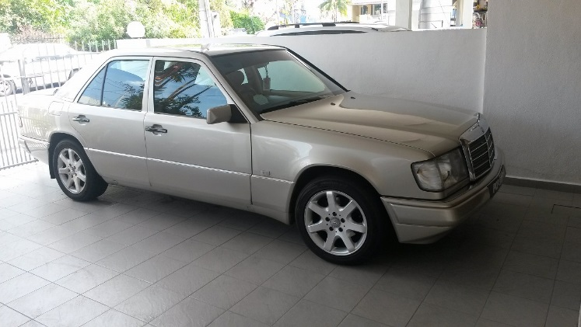 | 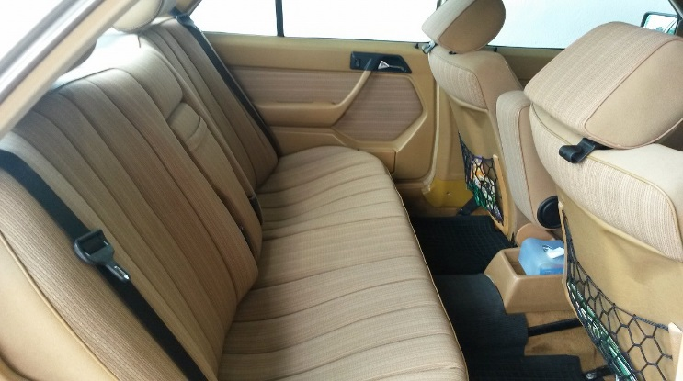
ZarikaTravel CAR PICTURES

*Coach - 44S -HINO

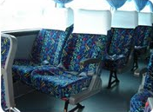
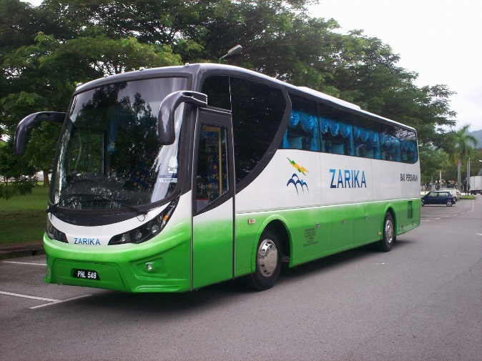

Capital One Leisure CAR PICTURES

*Coach - 44S -HINO

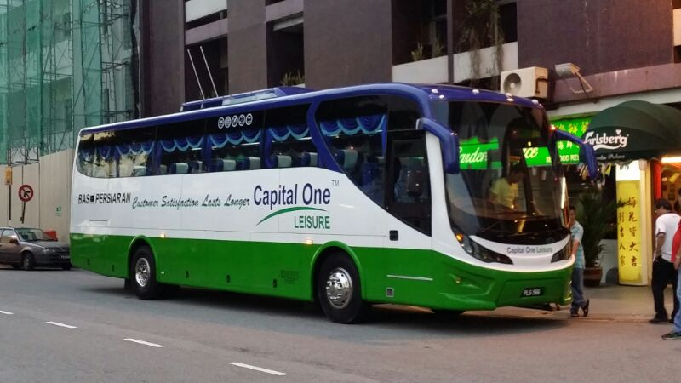

*Van - 16S – Joylong Farid
